November 2025
Subject: Diabetes Awareness Month

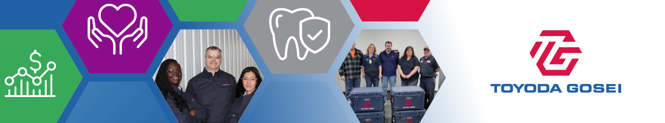
November is Diabetes Awareness Month
This month focuses on raising awareness about risk factors, encourages early detection and empowers individuals to take steps toward healthier lifestyles. It’s the perfect time to get educated, find resources and know what help is available through your TG benefits.
Symptoms and Screening
Symptoms of diabetes include excessive thirst, unexplained weight loss, constant fatigue, frequent urination and slow-healing wounds. Identifying these indicators early on can lead to timely intervention and management of diabetes. Additionally, blood sugar values from your annual preventive screening may indicate whether you’re at risk for diabetes. Be sure to discuss any concerns and questions with your doctor! | 
Managing Diabetes
Manage your “ABC” levels:
- A is for the A1C test that health care professionals use to measure your average blood glucose levels. Some people with diabetes also use devices to track their blood glucose throughout the day and night.
- B is for blood pressure.
- C is for cholesterol.
Take small steps toward healthy habits: Lifestyle habits such as planning healthy meals, being physically active, getting enough sleep, reaching or maintaining a healthy weight, and not smoking may help you manage diabetes.
Take your medicines on time: Remember to take your prescribed medications, even if you feel healthy. Talk with your doctor or pharmacist if you need help taking your medicine on time or at the correct dose.
Take care of your mental health: Getting diagnosed with a chronic illness can bring up a whole range of emotions and Optum’s Employee Assistance Program (EAP) counselors and clinicians can help. Contact the EAP at 800-622-7276 or visit liveandworkwell.com (password: TGNA) to get started.
TGNA Offers Resources to Help!  Virta Health can help if you’re pre-diabetic, looking to reverse Type 2 diabetes or need help with diabetes management. With Virta, you’ll be able to work on reversing diabetes, losing weight, achieving normal blood sugar, and getting back to good health. Virta provides no-cost access to physicians and nurses who can provide expert medical care, when and where you need it, via Virta’s custom-designed app. You will also receive a free blood sugar monitor, testing supplies, weight scale and food scale. |  | Contact Virta Health at 844-847-8216 or visit virtahealth.com/join/toyodagosei.

Want More Details About Your TG Benefits?
Be sure to visit our benefits website, tggroupbenefits.com (password: TGNA; location: United States).
There, you’ll find helpful information about all your benefits.

